# Lab 5 - Threat Intelligence connector and Content hub

This Lab will demonstrate how to use Microsoft Sentinel Threat Intelligence (TI) features and product integration points. During this Lab we rely on TI data that we ingested in earlier labs, so please make sure you have completed previous Labs. In this Lab we will also discover how to visualize and use this data as part of investigation and detection.

## Exercise 1 - Exploring the Microsoft Defender Threat Intelligence (Preview) connector

### Task 1 -- Enabling the Microsoft Defender Threat Intelligence (Preview) connector

This connector is currently in preview and ingests Microsoft Threat Intelligence indicators automatically into the ThreatIntelligenceIndicator table. MDTI provides a set of indicators and access to the https://ti.defender.microsoft.com portal at no additional cost, with the premium features of the MDTI portal and API requiring licensing.

**Note** -- The **Microsoft Defender Threat Intelligence (Preview)** connector was enabled in Lab 2 -- Task 2.

1. On the Azure Portal [**http://portal.azure.com**](urn:gd:lg:a:send-vm-keys), search for [**Microsoft Sentinel**](urn:gd:lg:a:send-vm-keys) and click on **Microsoft Sentinel**.

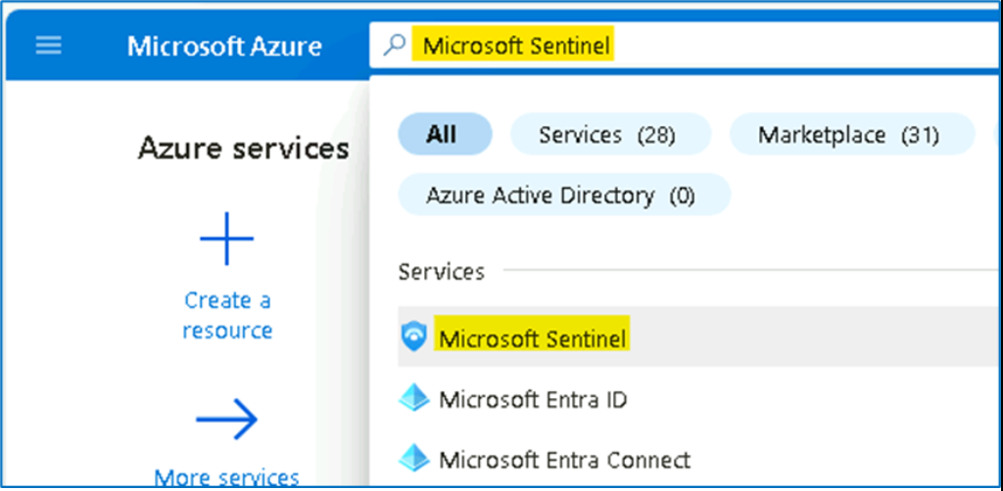

1. Select **SwrkXXXXXXX**.

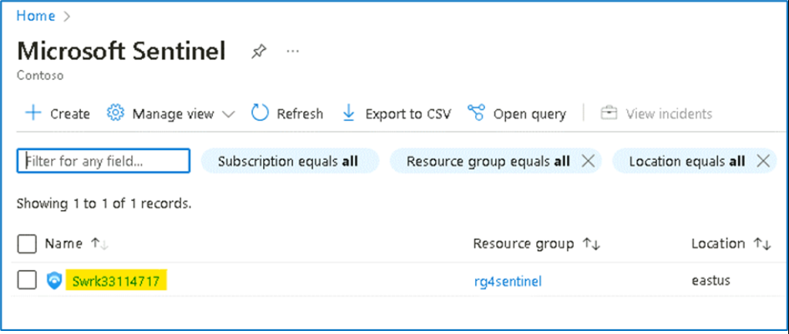

1. Click on **Data Connectors** under Configuration select **Microsoft Defender Threat Intelligence (Preview)**.

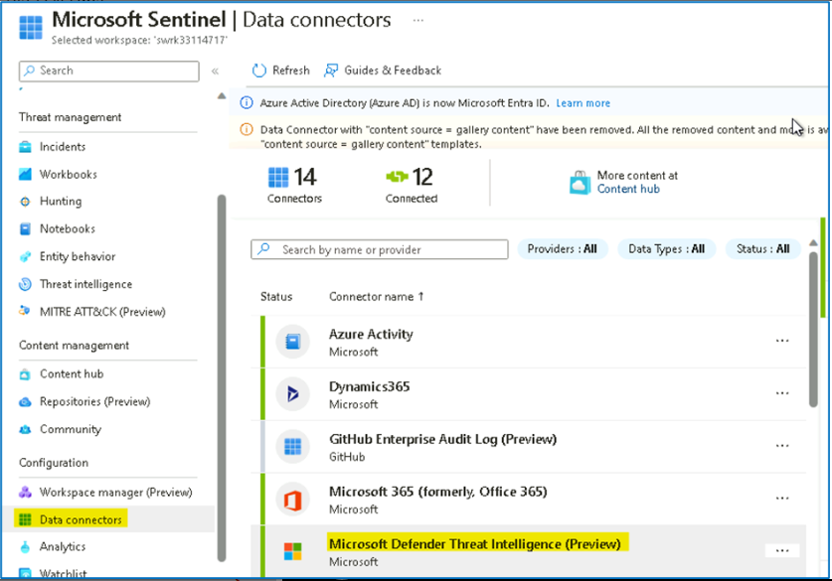

1. On the bottom right pane click on **Open connector page**

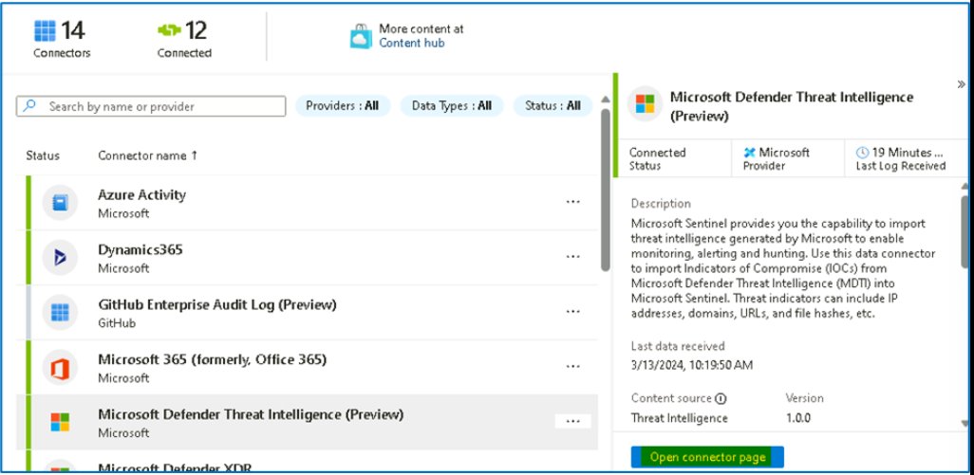

1. Review the data received and confirm that the connector is already ingesting indicators.

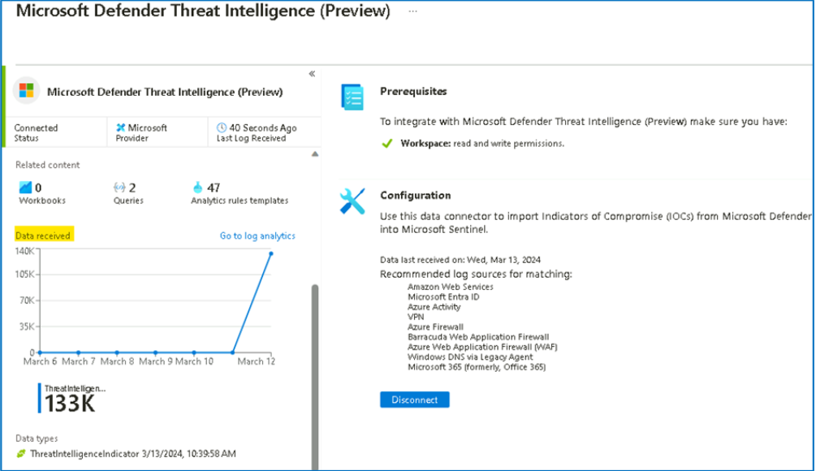

1. Close the **Microsoft Defender Threat Intelligence (Preview)** Connector page, to return to the Microsoft Sentinel home page.

### Task 2: Review and manage TI IOC's in Microsoft Sentinel Threat intelligence menu

After we ingested our TI data into the ThreatIntelligenceIndicator table, our mission is to review how our SOC can leverage and manage the TI menu to allow us to search, tag and manage the lifecycle of IOCs.

1. On the **Microsoft Sentinel** left menu click on the **Threat intelligence** under Threat management. This menu is a visual representation of the ThreatIntelligenceIndicator table. 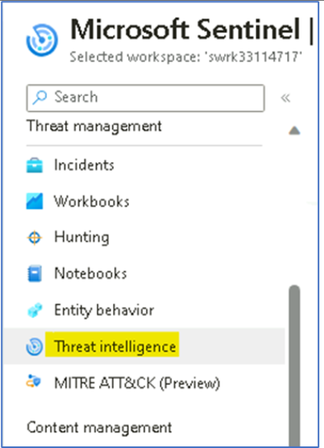
2. Select one IOC from the main pane and notice that the right pane changed accordingly and present the metadata of the selected IOC.

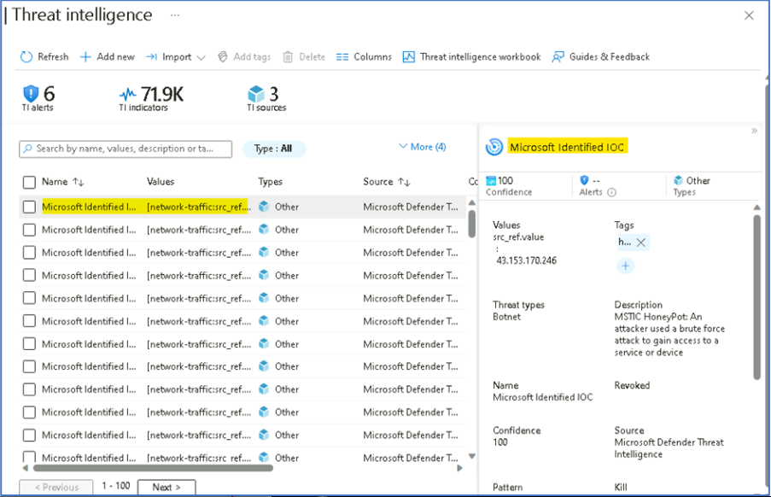

1. On the top area of the main blade, we can filter the list of the IOC's based on a specific parameters. In our case, we only ingested one type of IOC (IP), but the **Type** filter allow us to filter based on different types. If we ingested IOC's from multiple TI data sources, the **source** filter allows us to slice it.

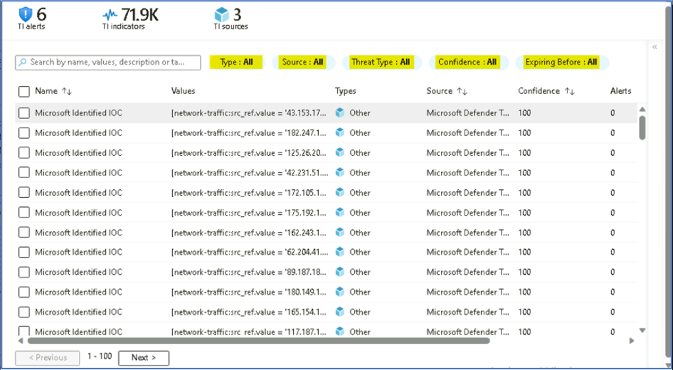

### Task 3 - Review the TI data into Microsoft Sentinel Logs interface.

The ingested Indicators of Compromise (IOC) coming from any of these TI feeds, is stored in a dedicated table called **ThreatIntelligenceIndicator**, and visible on the Threat Intelligence menu on the left navigation menu.

1. On the left navigation click on **Logs**, this will redirect you to the Log Analytics query interface. On the query interface we can see on the left side the tables with the relevant fields.

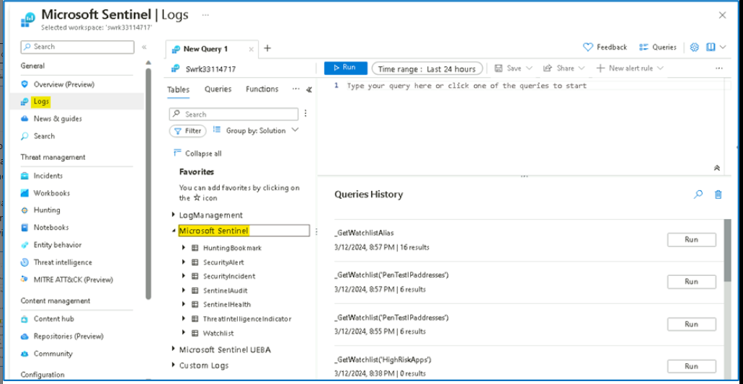

1. Microsoft Sentinel built-in tables have a predefined schema, to be able to see the **ThreatIntelligenceIndicator** schema, run the following query:

[**ThreatIntelligenceIndicato**](urn:gd:lg:a:send-vm-keys)**r**

[**| getschema**](urn:gd:lg:a:send-vm-keys)

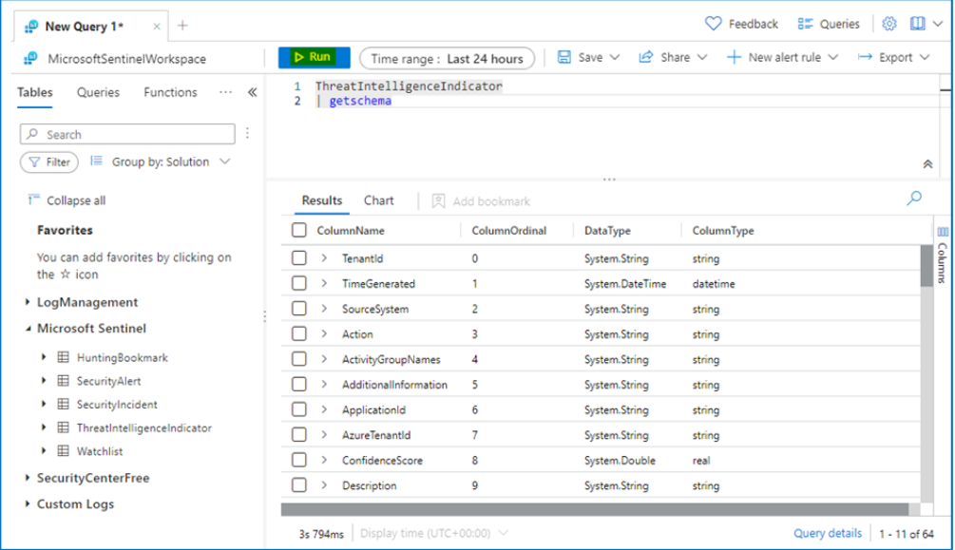

1. Let's explore and delve into the TI table. Run the following query which takes 10 records from the table:

[**ThreatIntelligenceIndicator**](urn:gd:lg:a:send-vm-keys)

[**| take 10**](urn:gd:lg:a:send-vm-keys)

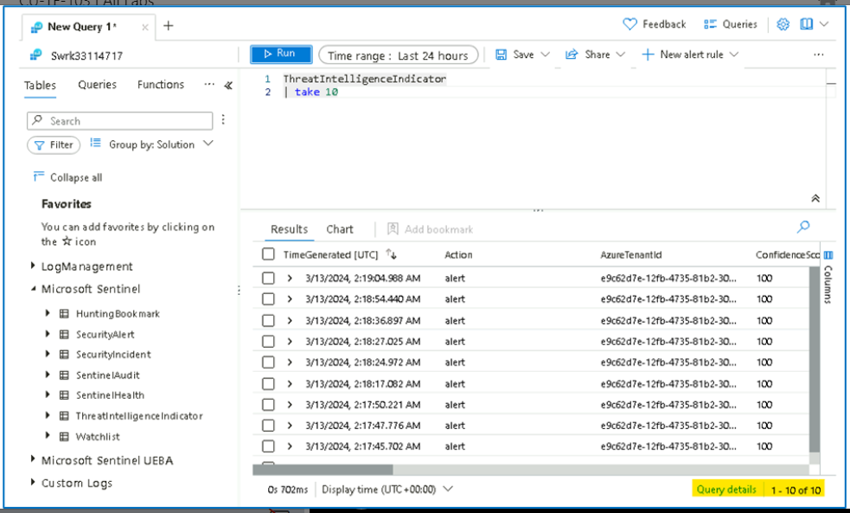

1. To understand if a specific IOC is active, we need to have a closer look at the following columns:
   * **ExpirationDateTime [UTC]**
   * **Acitve**

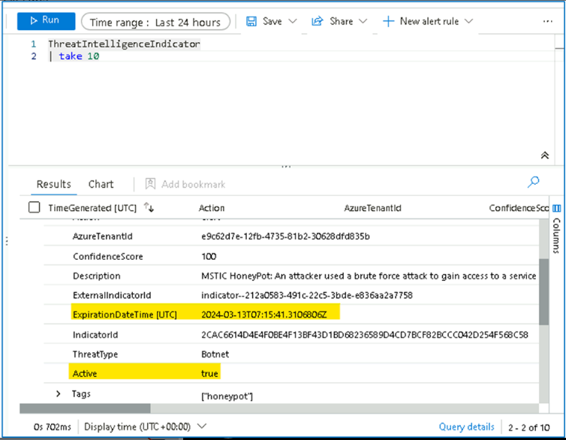

### Task 4 - Adding new TI IOC manually in Microsoft Sentinel Threat intelligence menu

Part of the SOC analyst's job is to manually add an IOC into the TI index from time to time. This allows other data sources and detections to correlate and detect interaction with this IOC.

1. On the **Threat intelligence** top menu, click on **Add new**,

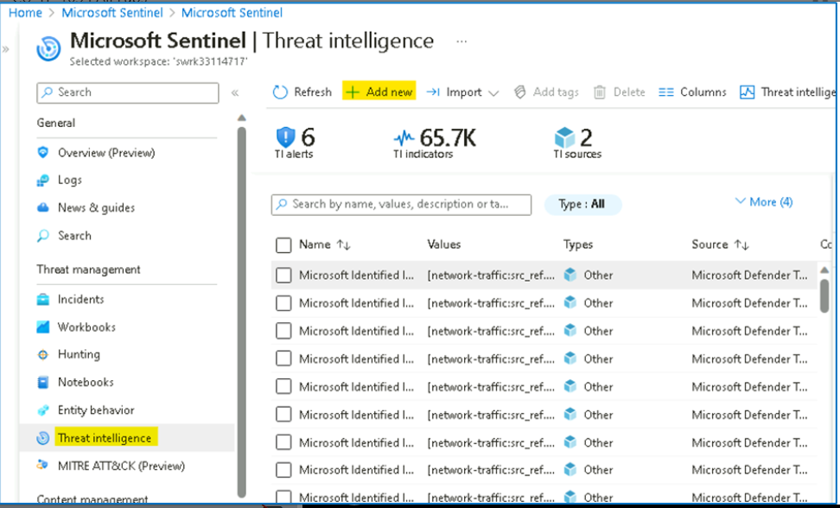

1. On the **New indicator** dialog provide the below details and then click on **Apply** button
   * Types -- **url**
   * URL - [**http://phishing.com**](urn:gd:lg:a:send-vm-keys)
   * Tags - [**Incident 4326**](urn:gd:lg:a:send-vm-keys)
   * Thread types - [**malicious-activity**](urn:gd:lg:a:send-vm-keys)
   * Description -- [**this URL is found in Incident 4326**](urn:gd:lg:a:send-vm-keys)
   * Name -- **[url indicator](urn:gd:lg:a:send-vm-keys" \o "Paste text into VM)**
   * Confidence level -- 80
   * Set the **Valid from** as today date
   * **Valid until** two weeks from today.

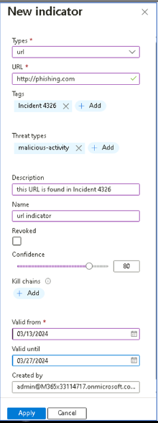

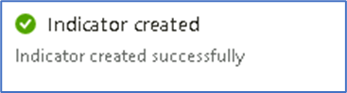

1. Notice to the newly created IOC on the TI menu.

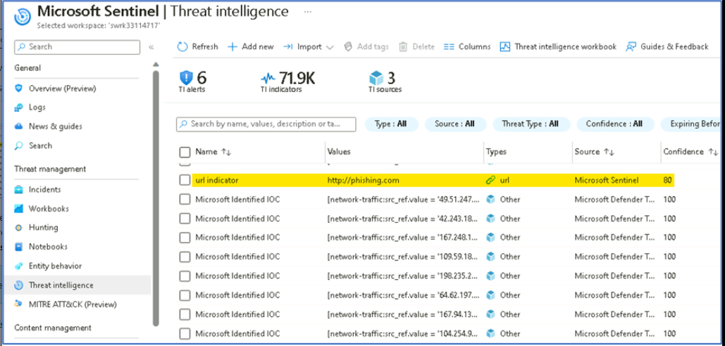

1. Be aware that every new IOC added in the TI menu, will be automatically added to the ThreatIntelligenceIndicator table. You can validate it by opening the **Logs** menu and run the query below.

**Note** -- It can take about 5 mins to have the result shown.

[**ThreatIntelligenceIndicator**](urn:gd:lg:a:send-vm-keys)

[**| search "http://phishing.com"**](urn:gd:lg:a:send-vm-keys)

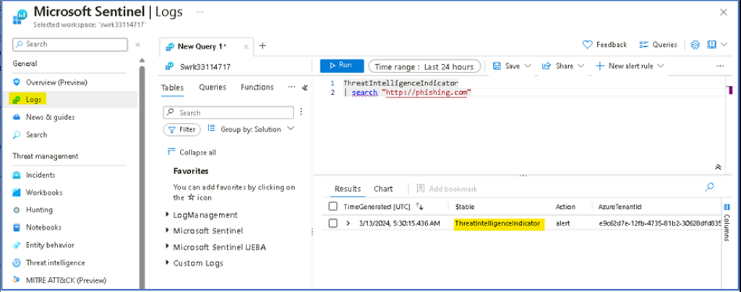

1. Select the newly created manual IOC and press **Delete** button.

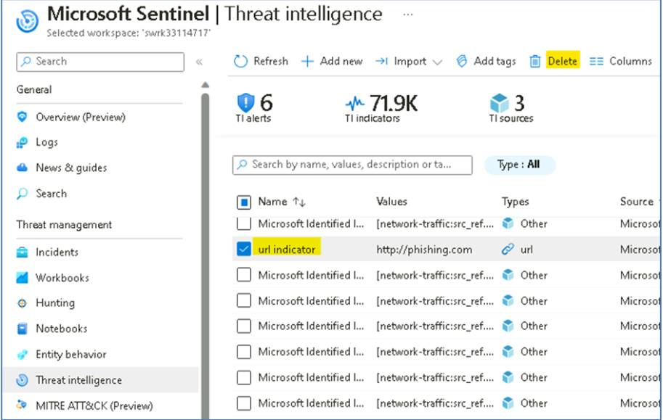

### Task 5 - Reviewing Analytics Rules based on Threat Intelligence data

1. From the **Microsoft Sentinel** page, click on **Analytics** and then click on the **Rule Templates** tab.

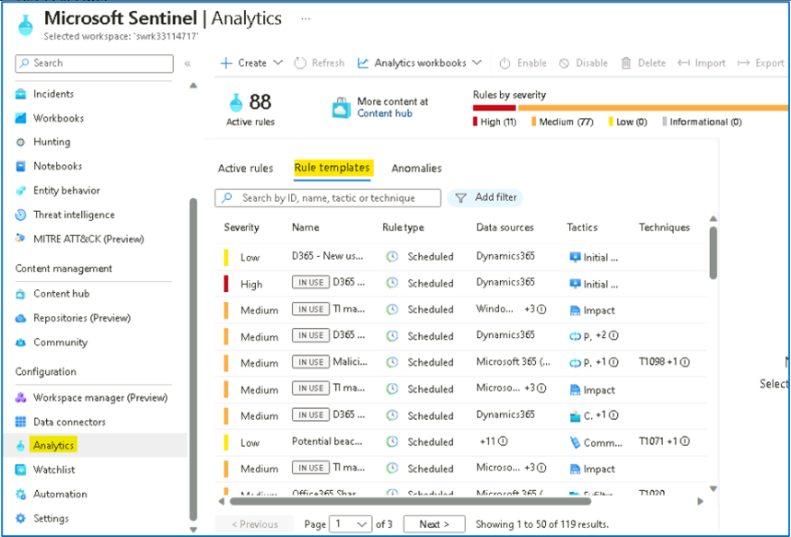

1. Click on **Add filter** and then select the **Data Sources** filter.

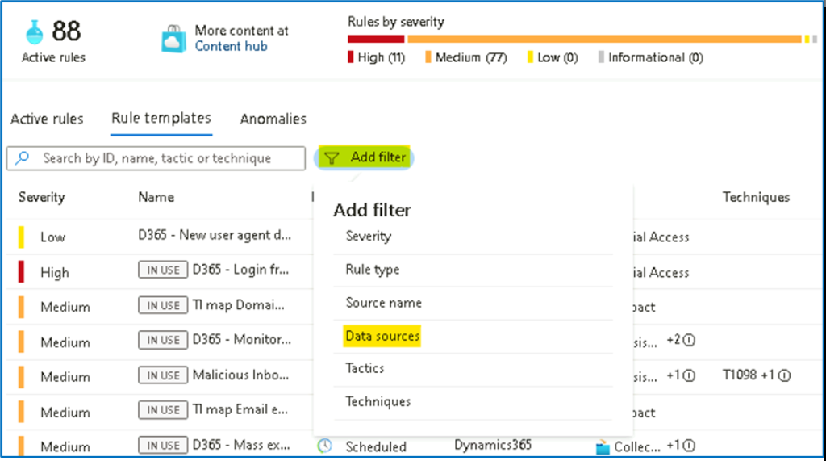

1. Select **Microsoft Defender Threat Intelligence (Preview).** Click **Apply** to apply the filter.

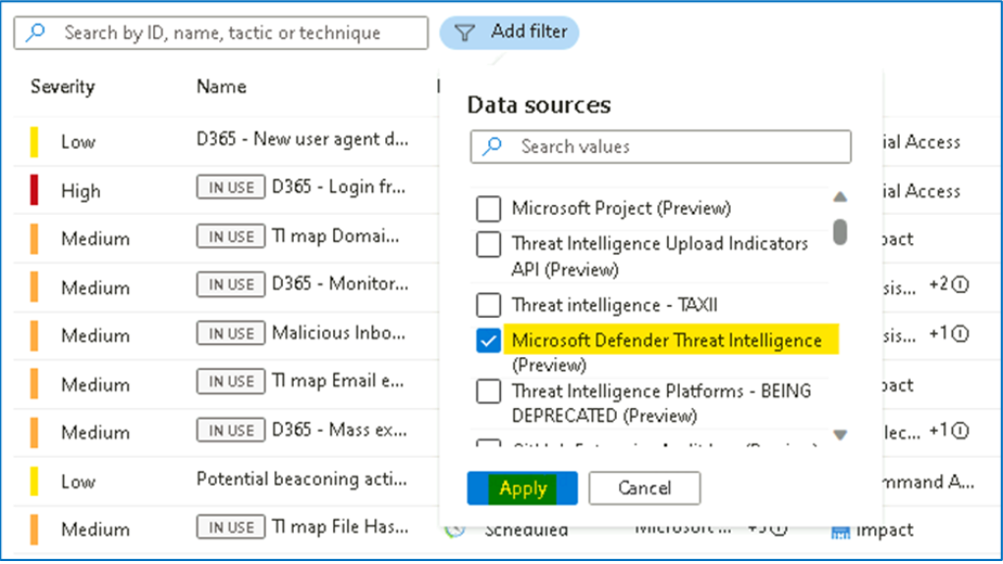

1. As you can see, there is a long list of resulting alert templates. These all will correlate your different data sources with the IOCs present in your TI table (**ThreatIntelligenceIndicator**), to detect any trace of malicious indicators of compromise in your organization's logs.

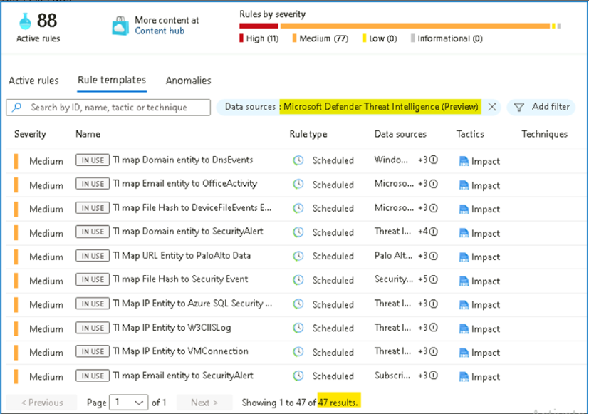

1. As you may know, it is free to enable analytics rules in Microsoft Sentinel, so the best practice is to enable all the ones that apply to data sources that you are ingesting.

### Task 6 - Enabling Threat Intelligence Matching Analytics rule

1. From the Microsoft Sentinel page, click on **Analytics** and click on **Rule Templates** tab. Clear previously applied filters if any.

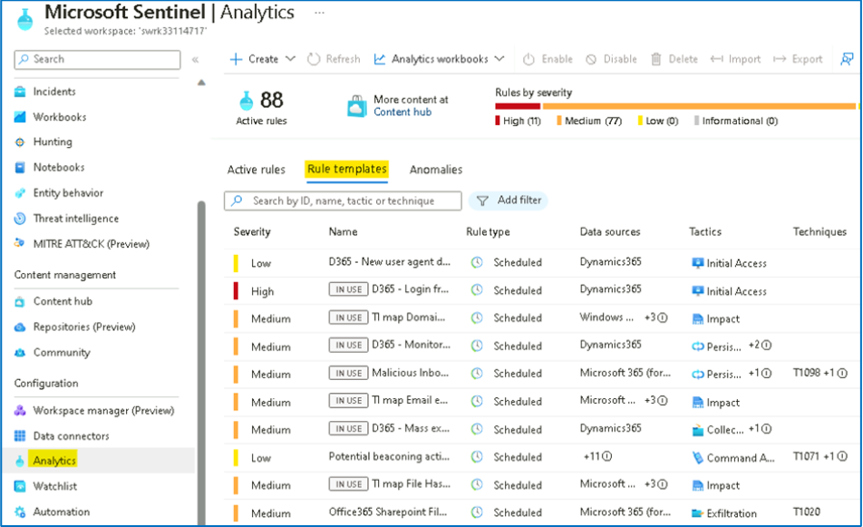

1. Click on Add filter and then choose **Rule Type** filter and select **Threat Intelligence**.

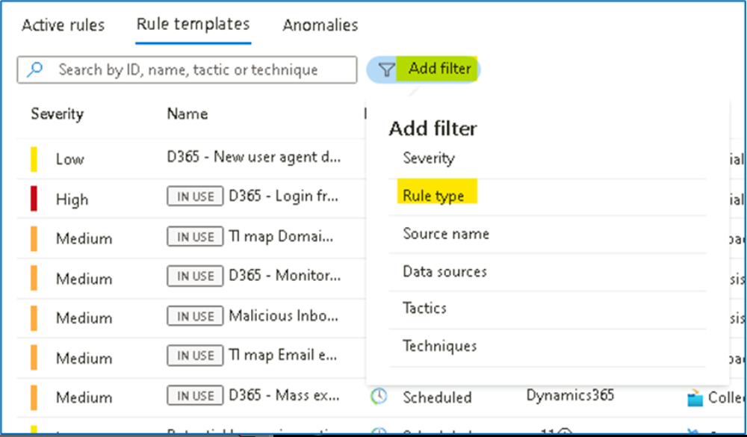

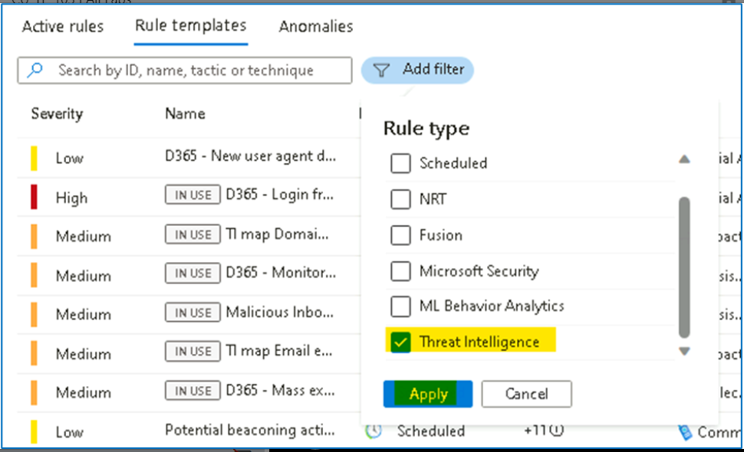

1. The resulting rule template matches Microsoft-generated threat intelligence data with the logs you have ingested into Microsoft Sentinel. The alerts are very high fidelity and are turned ON by default. Visit this link for more information about this type of rule.

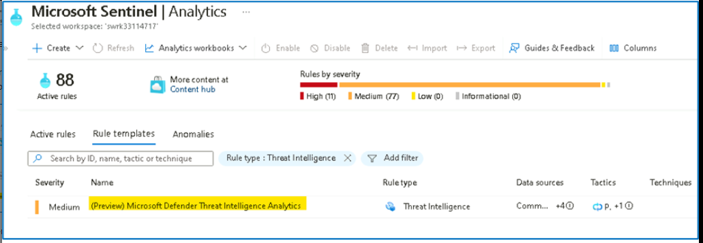

1. Select the rule template and notice the different data sources that are supported (at the time of writing, these are CEF, Syslog and DNS). Click on **Create rule**.

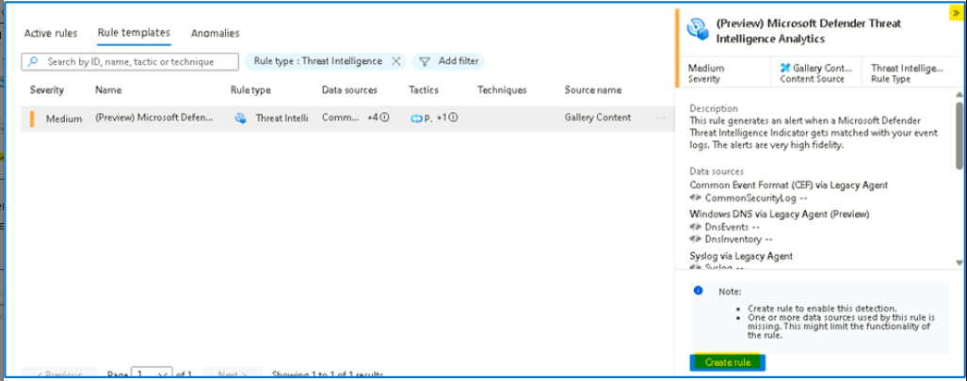

1. In the wizard, click on **Review and Create**.

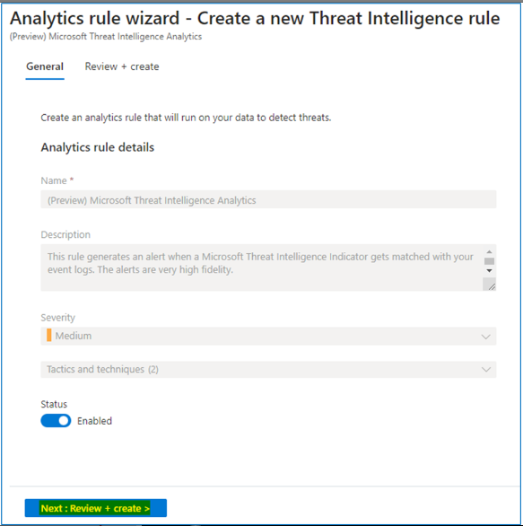

1. Click on the **Save** button to create the Rule

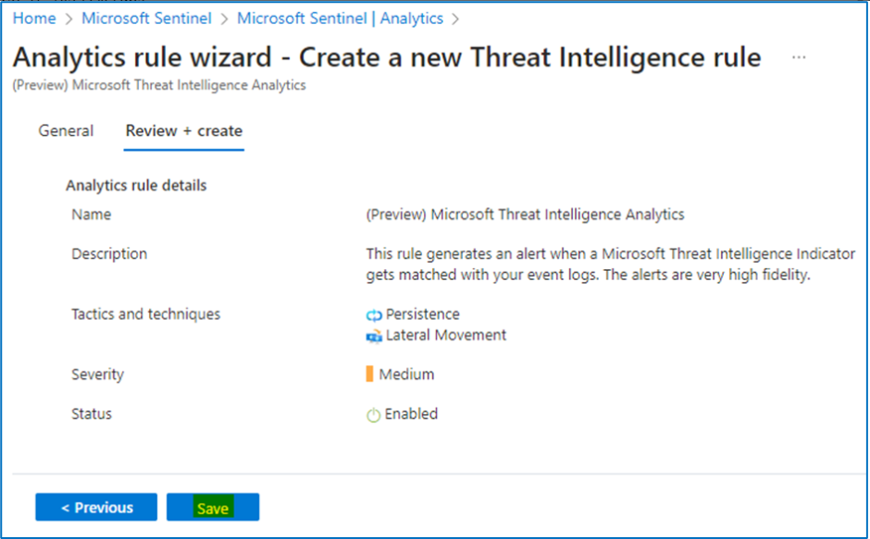

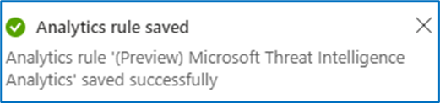

### Task 7 -- Explore and visualize Threat Intelligence workbook

1. While still on the **Microsoft Sentinel** page, click on **Workbooks** under **Threat management** and then click on **Add workbook**.

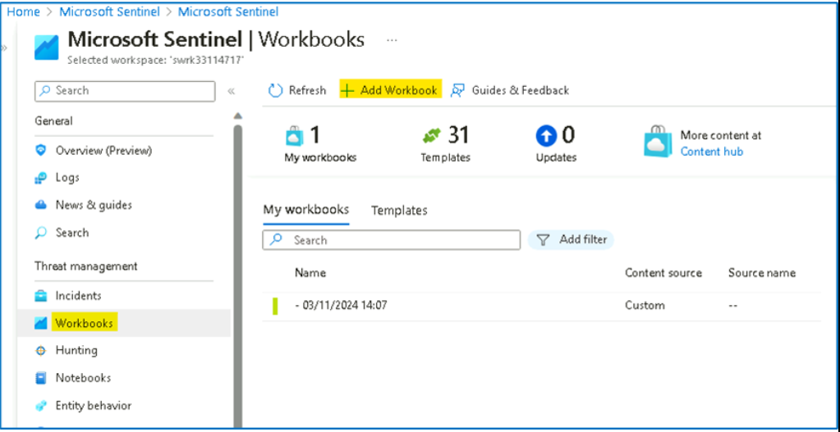

1. You will find some pre-built visualizations that show you the indicators imported into Sentinel over time, by type and provider. To modify or add a new chart, select the **Edit** button at the top of the page to enter editing mode for the workbook.

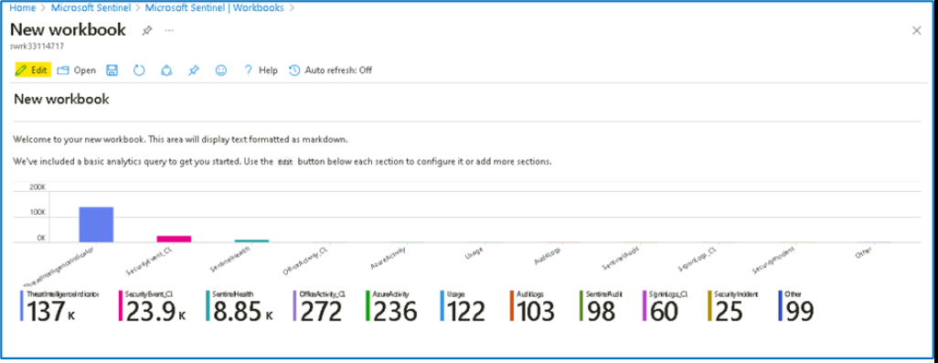

1. Add a new chart of threat indicators by threat type. To do this, scroll to the very bottom of the page and select **Add** > **Add Query**.

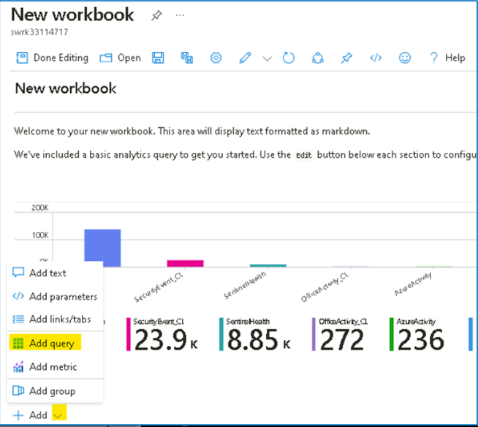

1. Add the following text to the Log Analytics workspace Log Query text box and then click on the **Run Query** button.

[**ThreatIntelligenceIndicator**](urn:gd:lg:a:send-vm-keys)

[**| summarize count() by ThreatType**](urn:gd:lg:a:send-vm-keys)

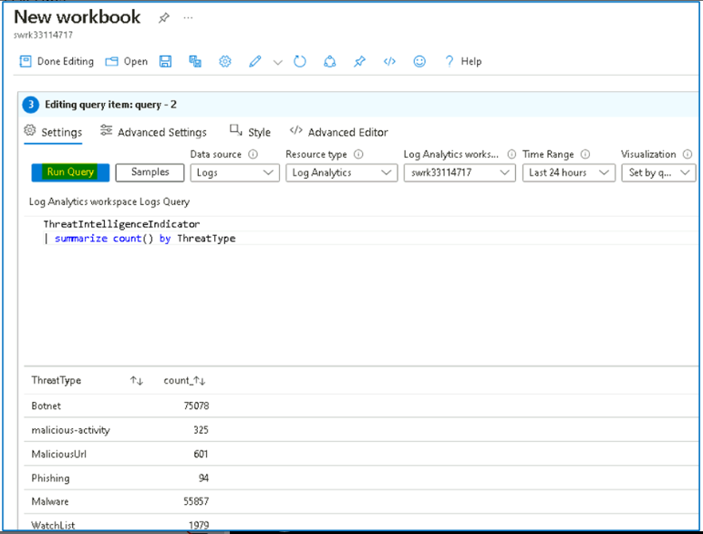

1. In the Visualization drop-down, select **Bar chart**.

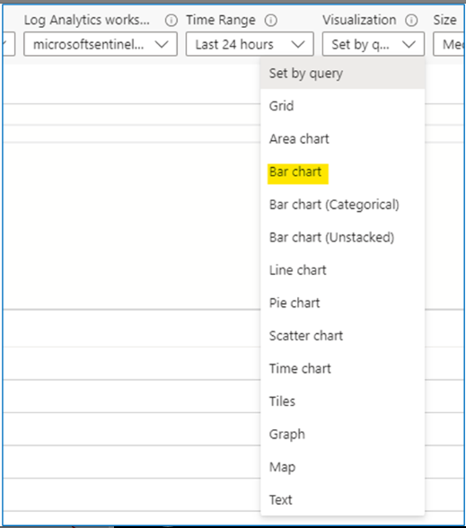

1. Select the **Done editing** button. You've created a new chart for your workbook.

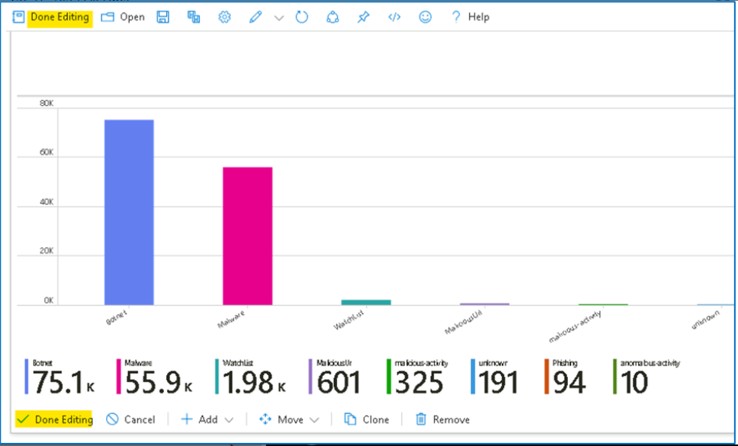

1. Click on the **Save** button and on the Workbook details tab, provide the Resource group details and then click on the **Apply** button.

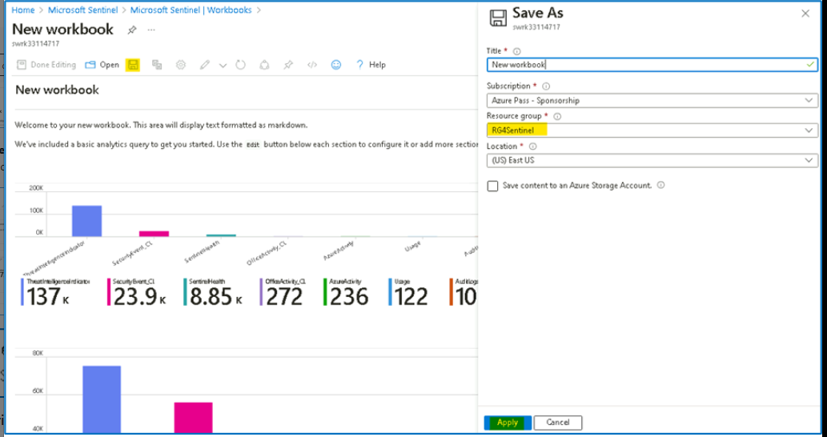

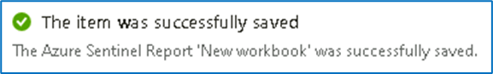

## Exercise 2 -- Exploring the Microsoft Sentinel Content hub.

### Task 1 -- Overview of Microsoft Sentinel Content hub

1. On the Azure Portal [**http://portal.azure.com**](urn:gd:lg:a:send-vm-keys), search for [**Microsoft Sentinel**](urn:gd:lg:a:send-vm-keys) and click on **Microsoft Sentinel**.

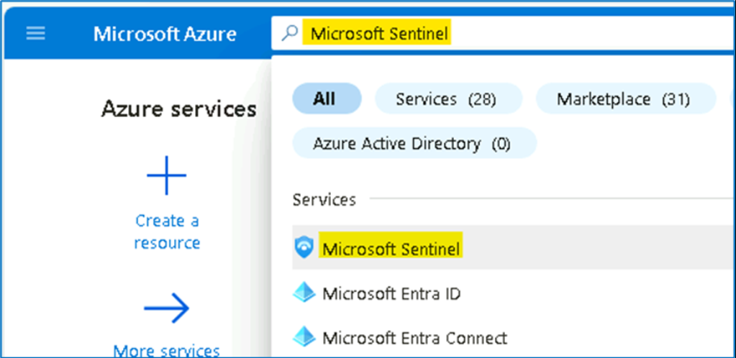

1. Select **SwrkXXXXXXX**.

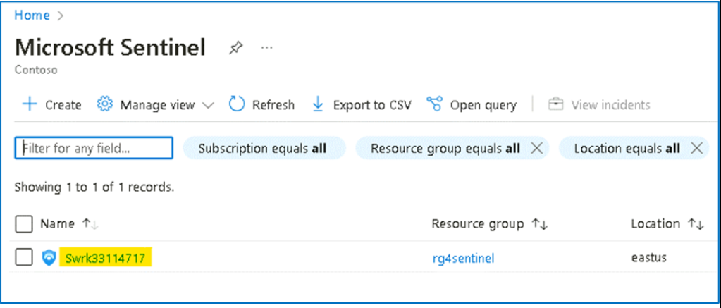

1. Now click **Content hub** under **Content Management**.

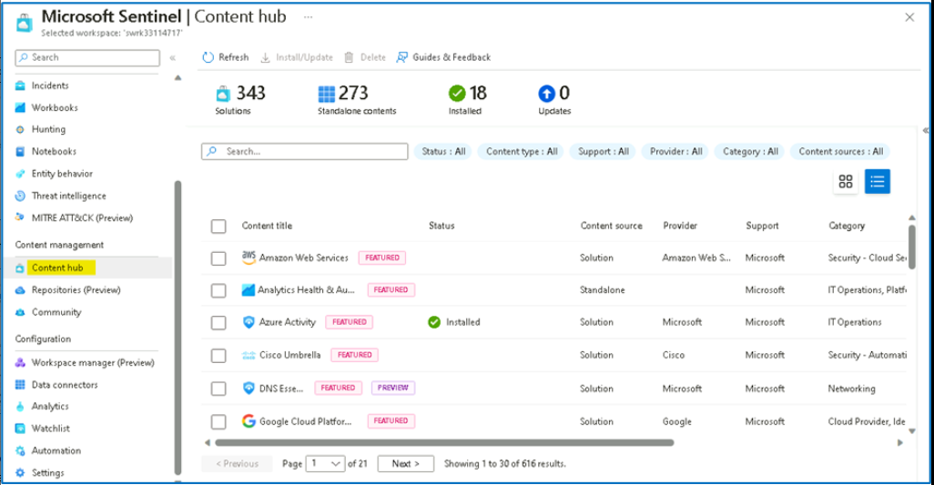

1. In the search bar, type [**Cloudflare**](urn:gd:lg:a:send-vm-keys). You will see a single result corresponding to Cloudflare solution. You could also search using the filtering options at the top.

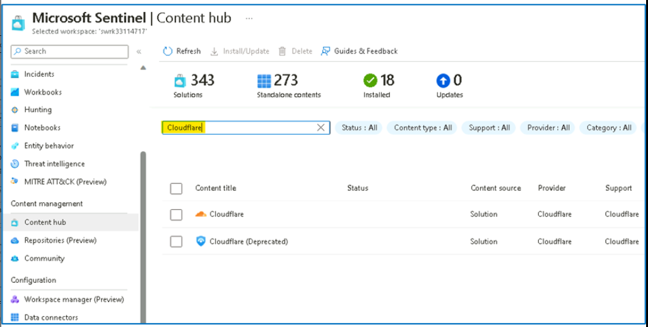

1. Select the Cloudflare solution. As you can see on the right pane, here we have information about this solution, like category, pricing, content types included, solution provider, version and also who supports it. Click **Install**.

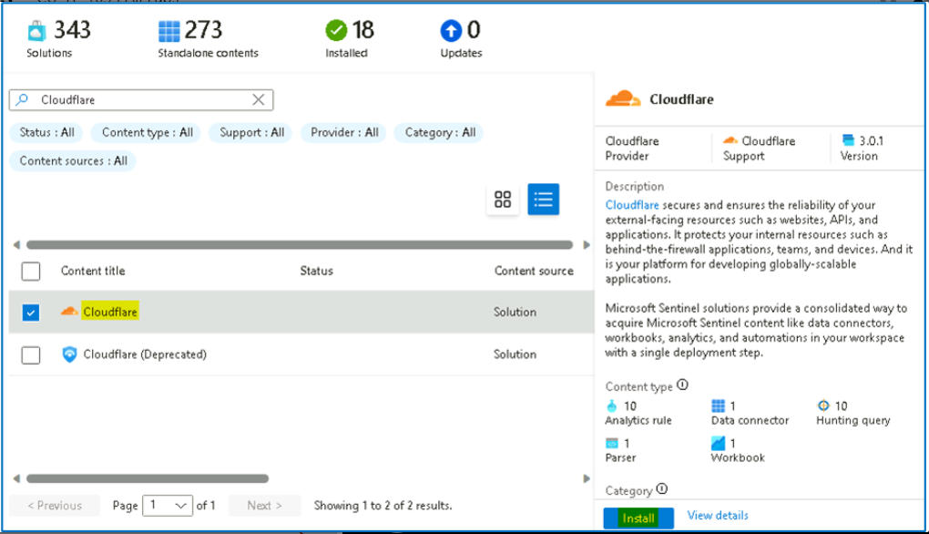

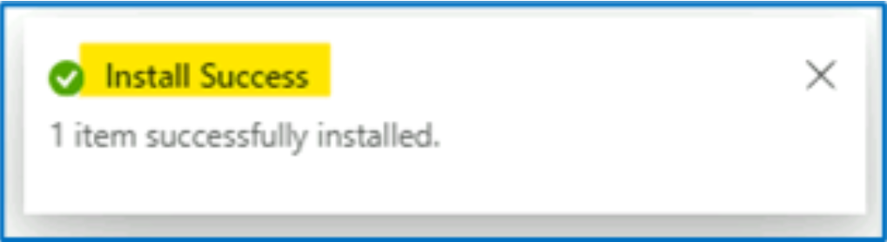

1. Click on the **Manage** button.

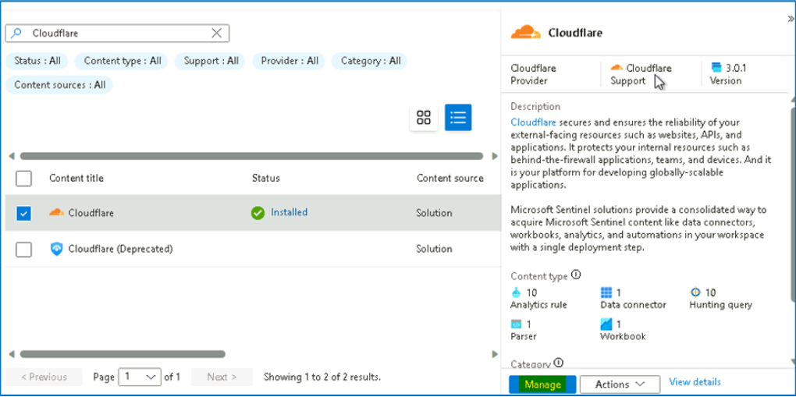

1. Notice the different artifacts that are included in this solution: **Data Connector, Parser, Workbook, Analytics Rules** and **Hunting Queries**. Each Solution can contain a different set of artifacts.

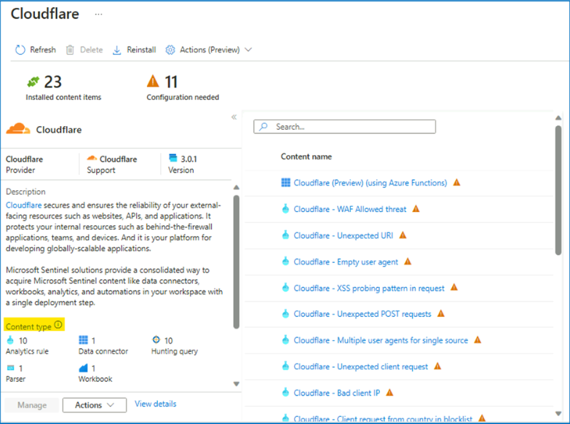

1. Close the **Cloudflare for Microsoft Sentinel** information page and you can navigate to other solutions. In the next exercise, we will install one of them.

### Task 2 - Deploying a new solution from Content hub

1. From the Microsoft Sentinel portal, navigate to **Content hub** under **Content Management**

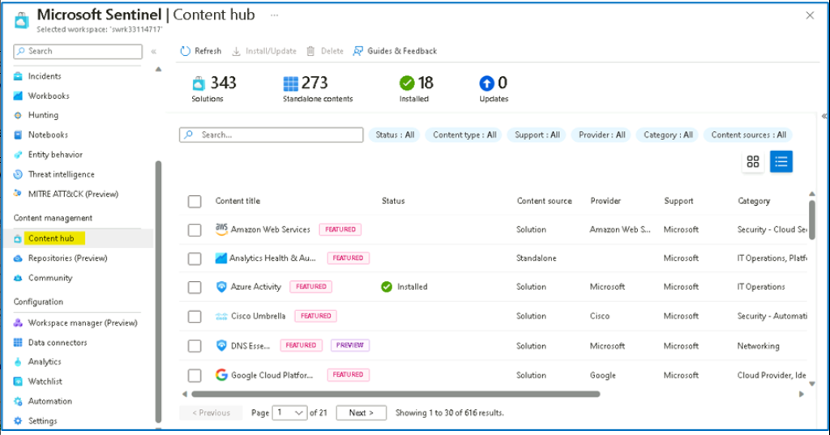

1. In the search bar, type [**dynamics 365 CE**](urn:gd:lg:a:send-vm-keys). Select on the **Dynamics 365 CE Apps** solution and click on **View Details**. Notice the content being added by this solution (Data Connector, Analytics Rules, Workbook, Hunting Queries and Watchlists).

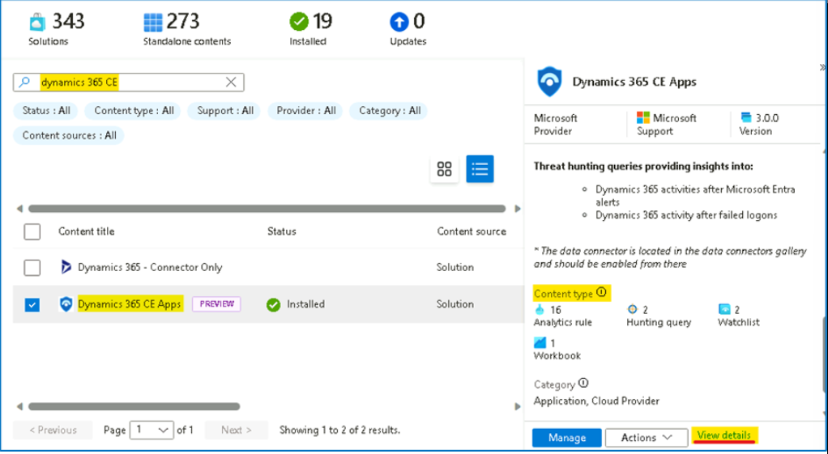

1. Click on **Create**.

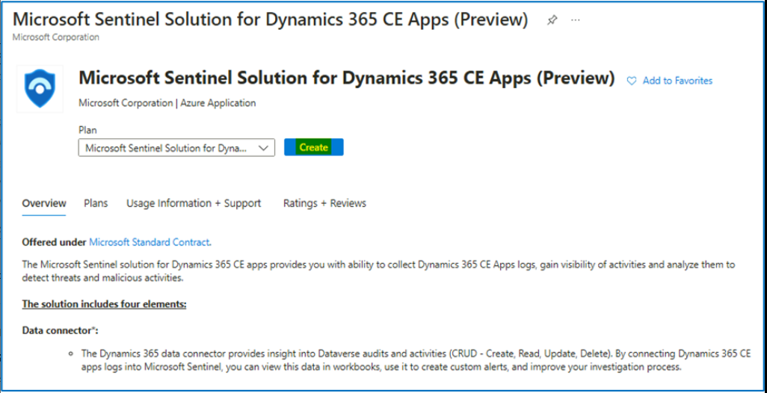

1. On the **Create Microsoft Sentinel Solution for Dynamics 365 CE Apps (Preview)** page provide the below details.

a. Subscription -- **Azure Pass -- Sponsorship**

b. Resource group -- **RG4Sentinel**

c. Workspace -- **Swrk33114717**

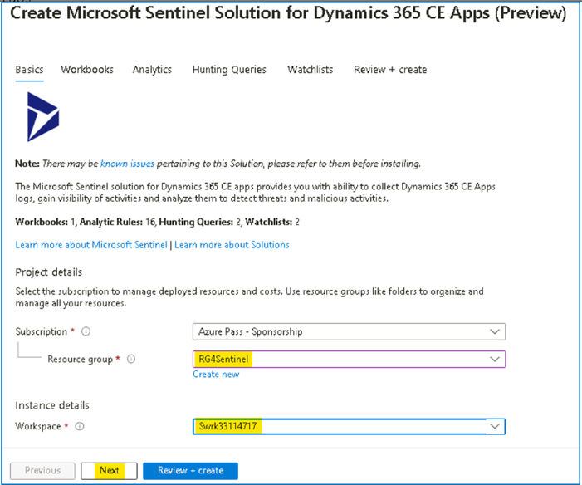

1. Click on **Next** and review the information on the **Workbooks** tab.

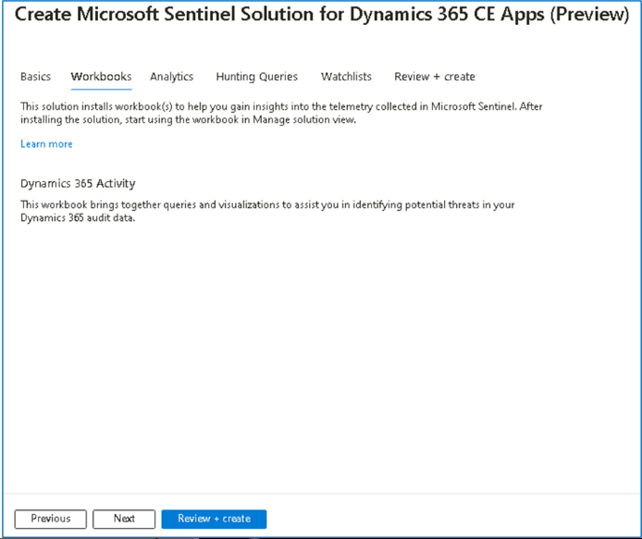

1. Click on **Next:** and review the information on **Analytics** tab.

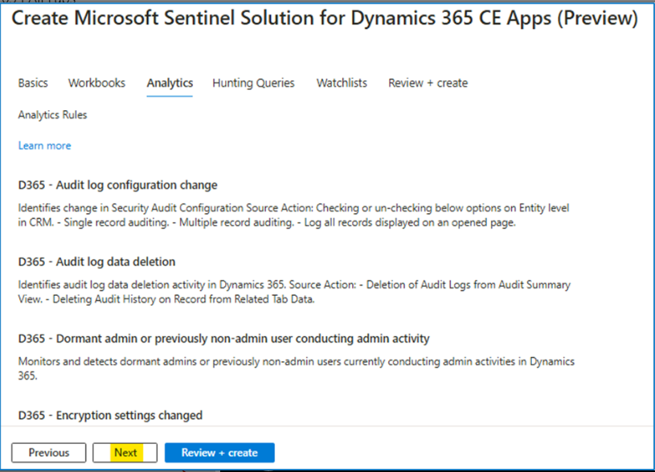

1. Notice the different **Analytics Rules** that will be added to your workspace. Click **Next.**

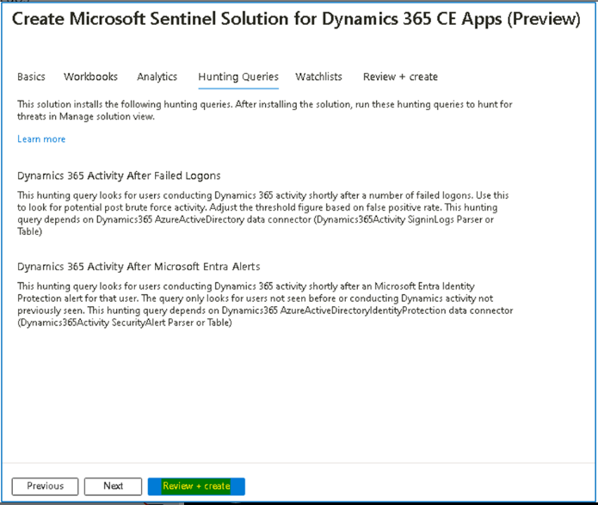

1. On the **Hunting Queries** tab, notice the Hunting Queries included in the solution. Click **Next: Review + create**.

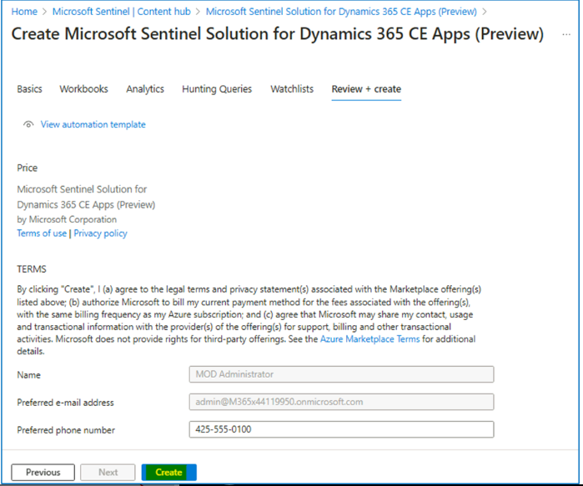

1. A final validation will run. If everything is ok, click on **Create** button. The deployment will kick off and finish in a few seconds.

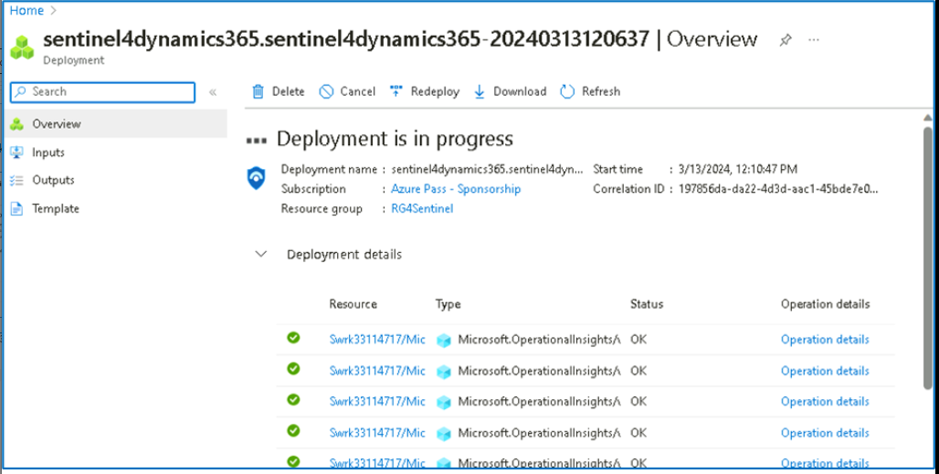

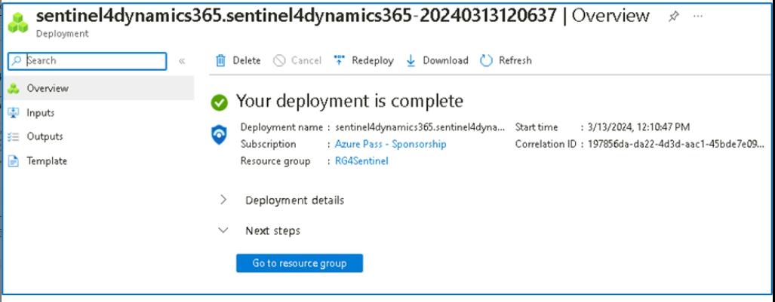

### Task 3 - Reviewing and enabling deployed artifacts

1. Navigate back to **Microsoft Sentinel** home page and click on **Analytics**, and select the **Rule Templates** tab.

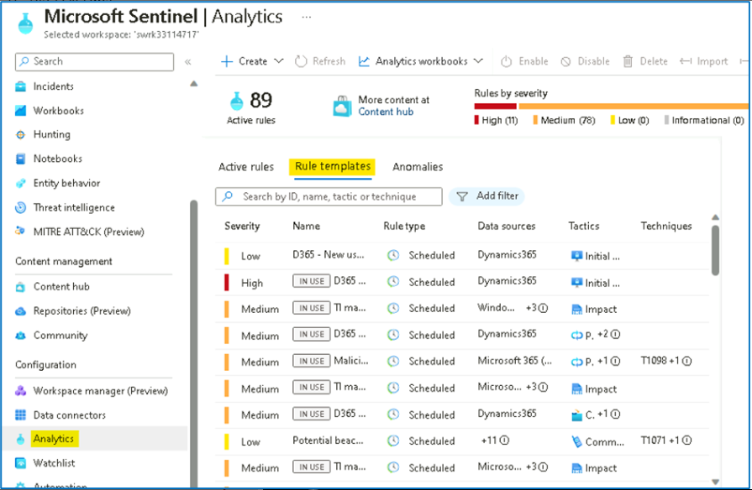

1. Type [**Dynamics**](urn:gd:lg:a:send-vm-keys) in the search box. You should see **16** different analytics rules that look at **Dynamics 365 data**.

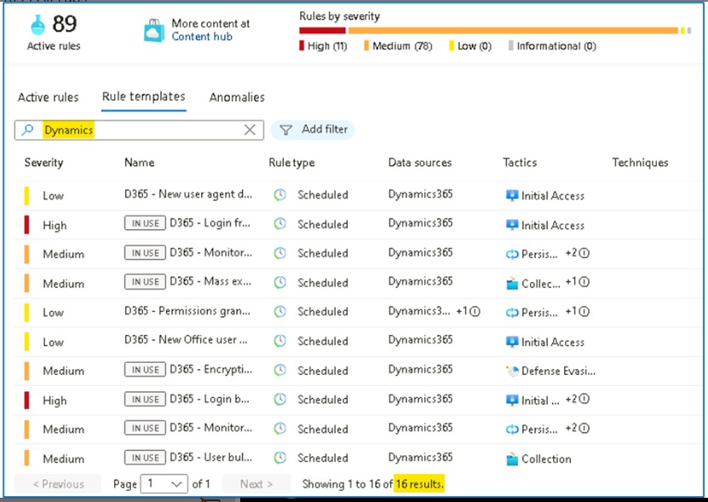

1. Notice that these rules are available as **templates**. In a real-world environment, you would need to create them in order to use them.
2. Navigate to **Workbooks** under Threat Management. Search for [**Dynamics**](urn:gd:lg:a:send-vm-keys) Like the analytics rules the workbook exists as a template. This should be empty unless you have enabled the Dynamics 365 connector.

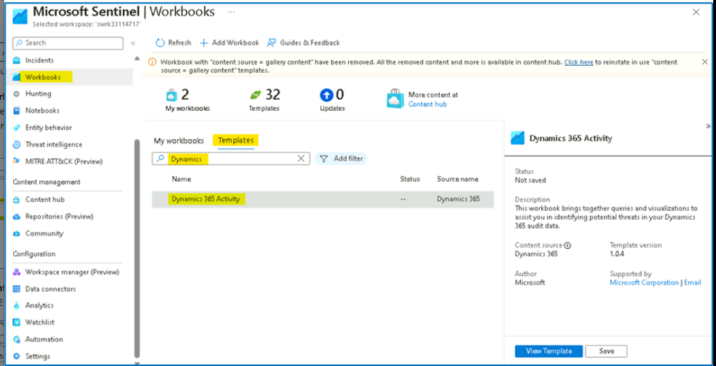

1. Navigate to **Hunting**, go to **Queries** tab and search for [**dynamics 365**](urn:gd:lg:a:send-vm-keys) You should see 2 new queries that use data coming from Dynamics 365.

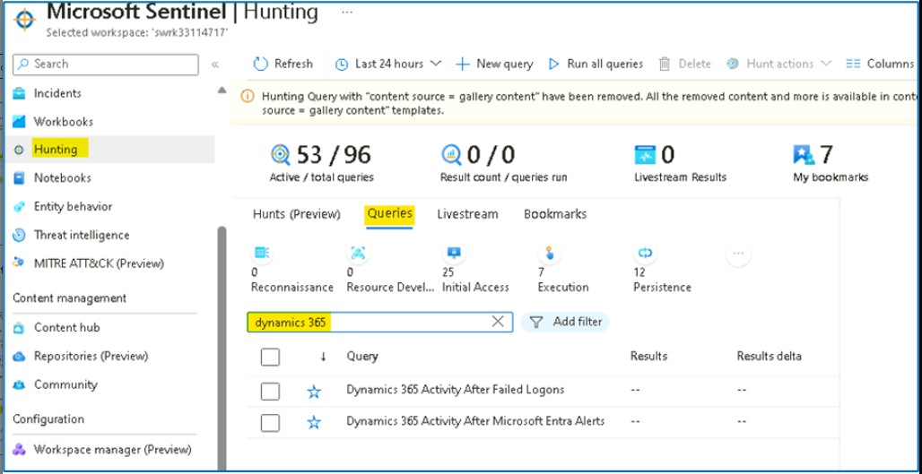

1. Navigate to **Watchlist** under Configuration. Search for [**d365**](urn:gd:lg:a:send-vm-keys). Notice you have two new watchlists.

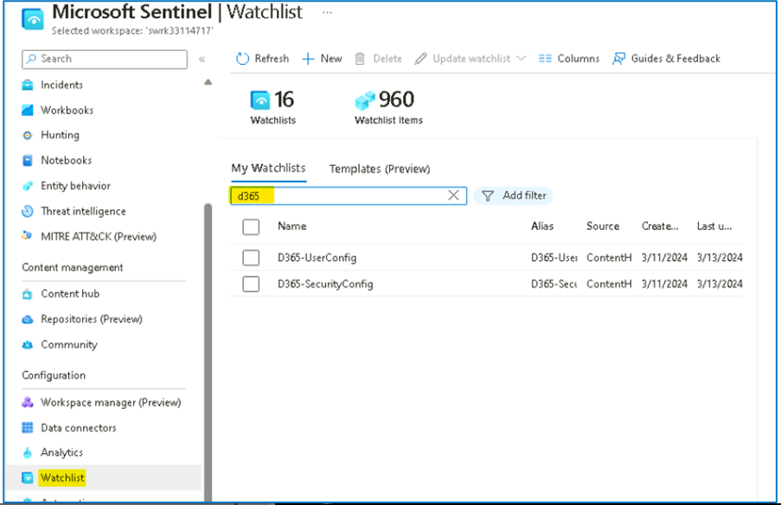

Congratulations, you have completed Lab 5!